

Assessment Report

On

“***Classify Plants Based on Water Needs”***

submitted as partial fulfillment for the award of

BACHELOR OF TECHNOLOGY

DEGREE

SESSION 2024-25

In

CSE(AI)

By

Name : Ananya Sharma

Roll Number : 202401100300038

Section: A

**Under the supervision of**

***“BIKKI GUPTA”***

KIET Group of Institutions, Ghaziabad

May, 2025

1. **Introduction**

This project aims to classify plants based on their water needs, using environmental factors like sunlight hours, watering frequency, and soil type. The primary objective is to predict whether a plant requires low, medium, or high water based on these features.

A machine learning model, specifically **Gradient Boosting**, is employed for classification, and class imbalance is addressed using **SMOTE** (Synthetic Minority Over-sampling Technique). The model's performance is evaluated using accuracy, precision, recall, and F1-score to ensure reliable predictions. This project is useful for optimizing plant care by accurately determining water requirements based on environmental conditions, which can improve gardening and agricultural practices.

1. **Problem Statement**

Classify plants into low, medium, or high water‑need categories using sunlight hours, watering frequency, and soil type. Balance classes with SMOTE and employ a Gradient Boosting classifier to automate accurate water‑requirement predictions for optimized plant care.

**3. Objective**

* Preprocess and encode environmental features (sunlight hours, watering frequency, soil type) for modeling.
* Balance the target classes using SMOTE to mitigate dataset imbalance.
* Train a Gradient Boosting classifier to predict plant water‑need categories (low, medium, high).
* Evaluate the model’s performance using accuracy, precision, recall, and F1‑score.
* Provide reliable, data‑driven recommendations to optimize plant watering practices.

# 4. Methodology

1. **Data Preprocessing:** The dataset is loaded and cleaned by encoding categorical variables (soil_type and water_need) into numeric values using Label Encoding. This step ensures the data is suitable for machine learning models.
2. **Handling Class Imbalance:** To address the class imbalance in the target variable (water_need), SMOTE (Synthetic Minority Over-sampling Technique) is applied to generate synthetic samples for minority classes, improving model performance**.**
3. **Feature Selection:** The relevant features, including sunlight_hours, watering_freq_per_week, and soil_type_encoded, are selected to train the model.
4. **Model Training:** A Gradient Boosting Classifier is used to train the model on the resampled data. The model is then evaluated on an 80-20 train-test split.
5. **Evaluation:** The model's performance is assessed using accuracy, precision, recall, and F1-score to ensure reliable classification of plant water needs.

# Code

import pandas as pd

df = pd.read_csv('plants.csv')

df.head()

df.info()

print("\n")

print("Look at unique values for each column")

for col in df.columns:

    print(f"{col}: {df[col].unique()}")

print(df['water_need'].value_counts())

from sklearn.model_selection import train_test_split

from sklearn.preprocessing import LabelEncoder

from sklearn.ensemble import GradientBoostingClassifier

from imblearn.over_sampling import SMOTE

from sklearn.metrics import accuracy_score, classification_report

data = pd.read_csv('plants.csv')

soil_encoder = LabelEncoder()

data['soil_type_encoded'] = soil_encoder.fit_transform(data['soil_type'])

target_encoder = LabelEncoder()

data['water_need_encoded'] = target_encoder.fit_transform(data['water_need'])

X = data[['sunlight_hours', 'watering_freq_per_week', 'soil_type_encoded']]

y = data['water_need_encoded']

smote = SMOTE(random_state=42)

X_resampled, y_resampled = smote.fit_resample(X, y)

X_train, X_test, y_train, y_test = train_test_split(X_resampled, y_resampled, test_size=0.2, random_state=42)

model = GradientBoostingClassifier(random_state=42)

model.fit(X_train, y_train)

y_pred = model.predict(X_test)

accuracy = accuracy_score(y_test, y_pred)

print("Accuracy:", accuracy)

print("\nClassification Report:")

print(classification_report(y_test, y_pred, target_names=target_encoder.classes_))

1. **OUTPUT**

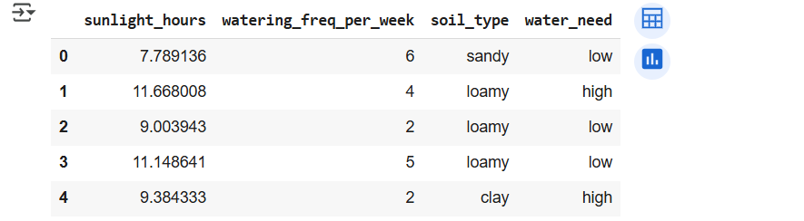

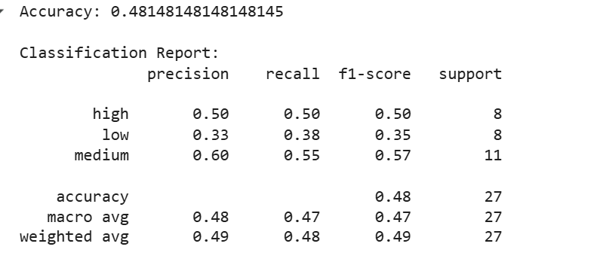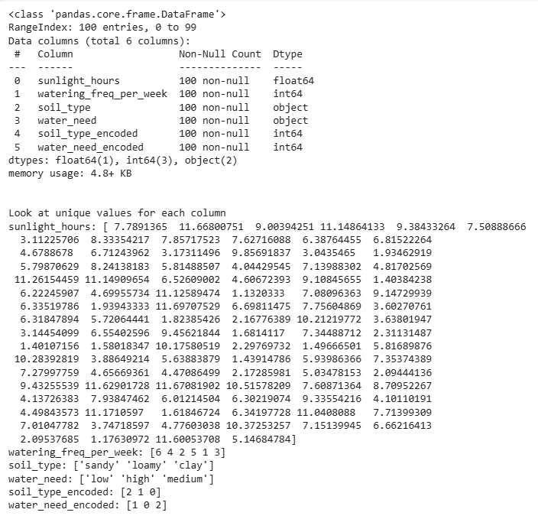

1. **References**

* Given dataset : “plants.csv” .
* Matplotlib Documentation: [https://matplotlib.org](https://matplotlib.org/)
* Pandas Documentation: <https://pandas.pydata.org>
* Scikit documentation: <https://scikit-learn.org/stable/modules/generated/sklearn.ensemble.GradientBoostingClassifier.html>